### **Honey Glazed Salmon**

*This honey-glazed salmon is the perfect dinner for anyone looking for something high in protein. It’s full of healthy nutrients and is overall just delicious!*

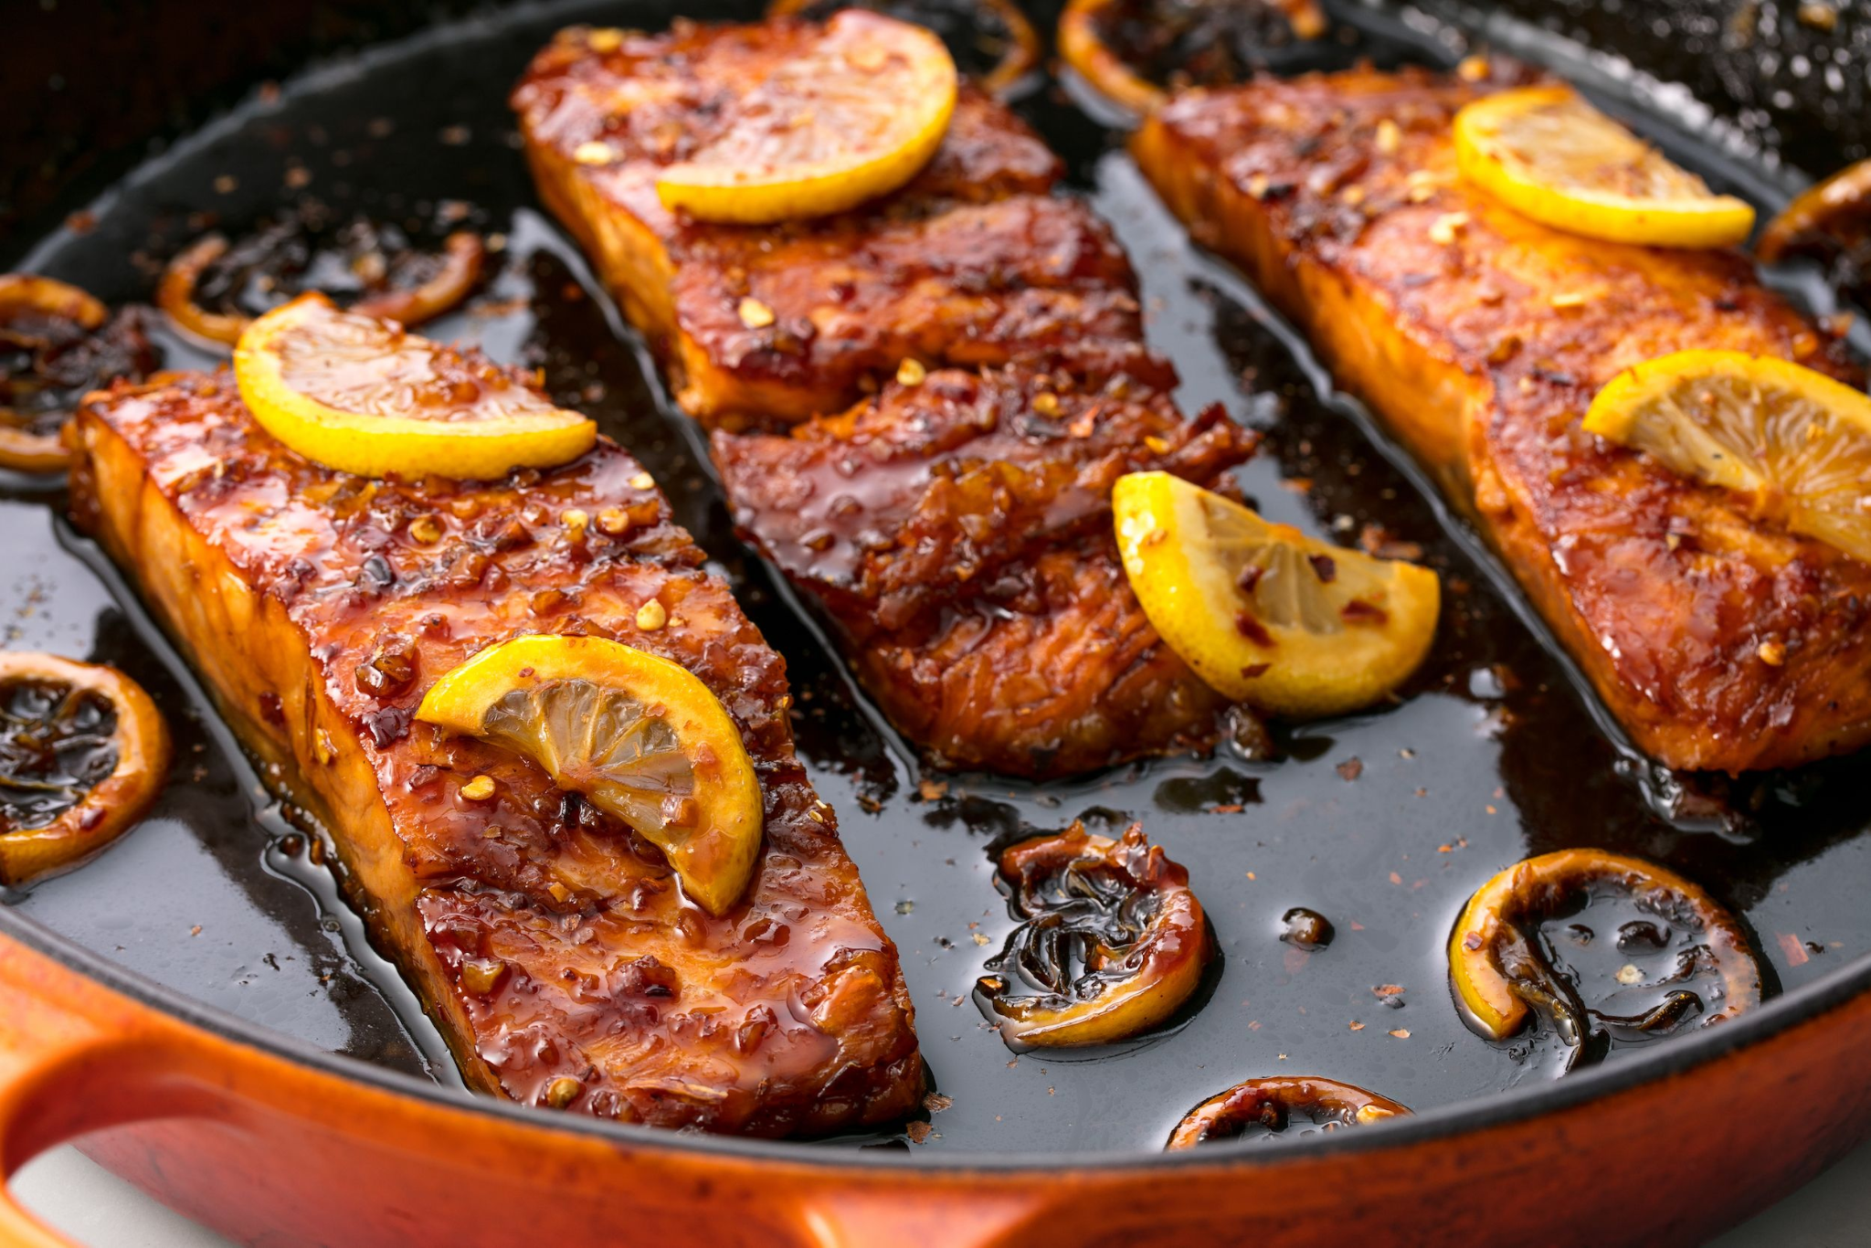

### **Ingredients:**

#### **SALMON**

* 4 (6 oz each) salmon filets
* 1/2 tsp kosher salt
* 1/2 tsp black pepper
* 1/2 tsp smoked paprika *(or regular paprika)*
* 1/4 tsp blackening seasoning *(optional)*

#### **SAUCE**

* 3 Tbsp butter
* 2 tsp olive oil
* 6 cloves garlic *minced*
* 1/2 cup honey
* 3 Tbsp water
* 3 Tbsp soy sauce
* 1 Tbsp sriracha sauce
* 2 Tbsp lemon juice

### **Instructions**

1. Pat salmon dry, then season with salt, pepper, paprika and blackening seasoning (if using). Set aside. Adjust oven rack to middle position, then preheat broiler.
2. Add butter and oil to a large, oven-safe skillet over MED-HIGH heat. Once butter is melted, add garlic, water, soy sauce, sriracha, honey and lemon juice and cook 30 seconds or so, until sauce is heated through.
3. Add salmon, skin side down (if using salmon with skin), and cook 3 minutes. While salmon cooks, baste frequently with sauce from the pan by spooning it over the top of the salmon.
4. Broil salmon for 5-6 minutes, basting with sauce once during the broil, until salmon is caramelized and cooked to desired doneness.
5. Garnish with minced parsley if desired and add a side of vegetables such a broccoli

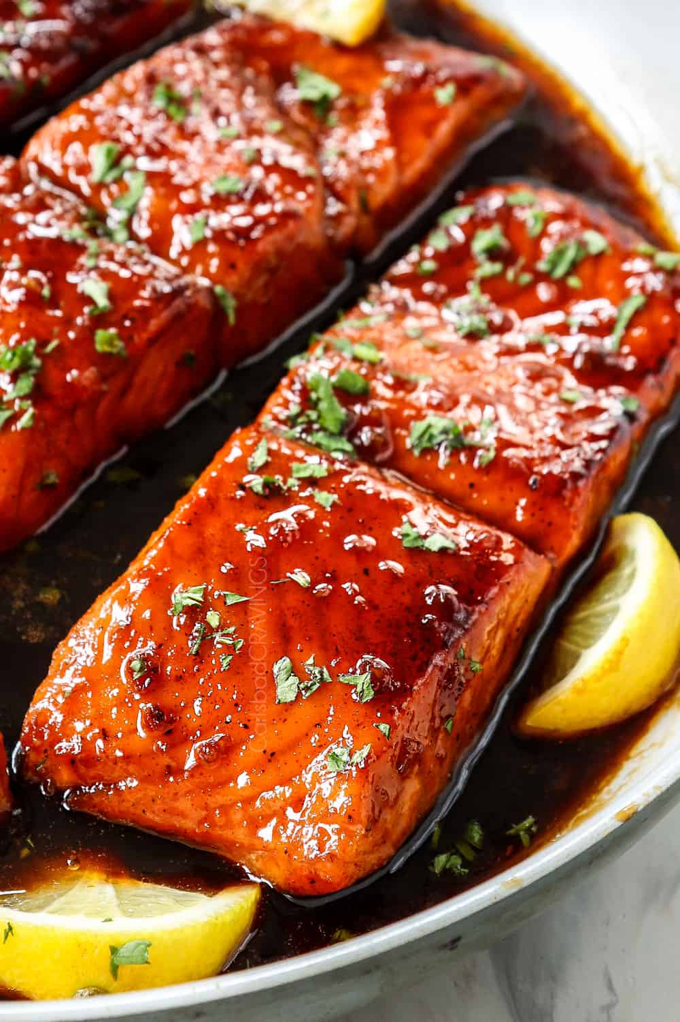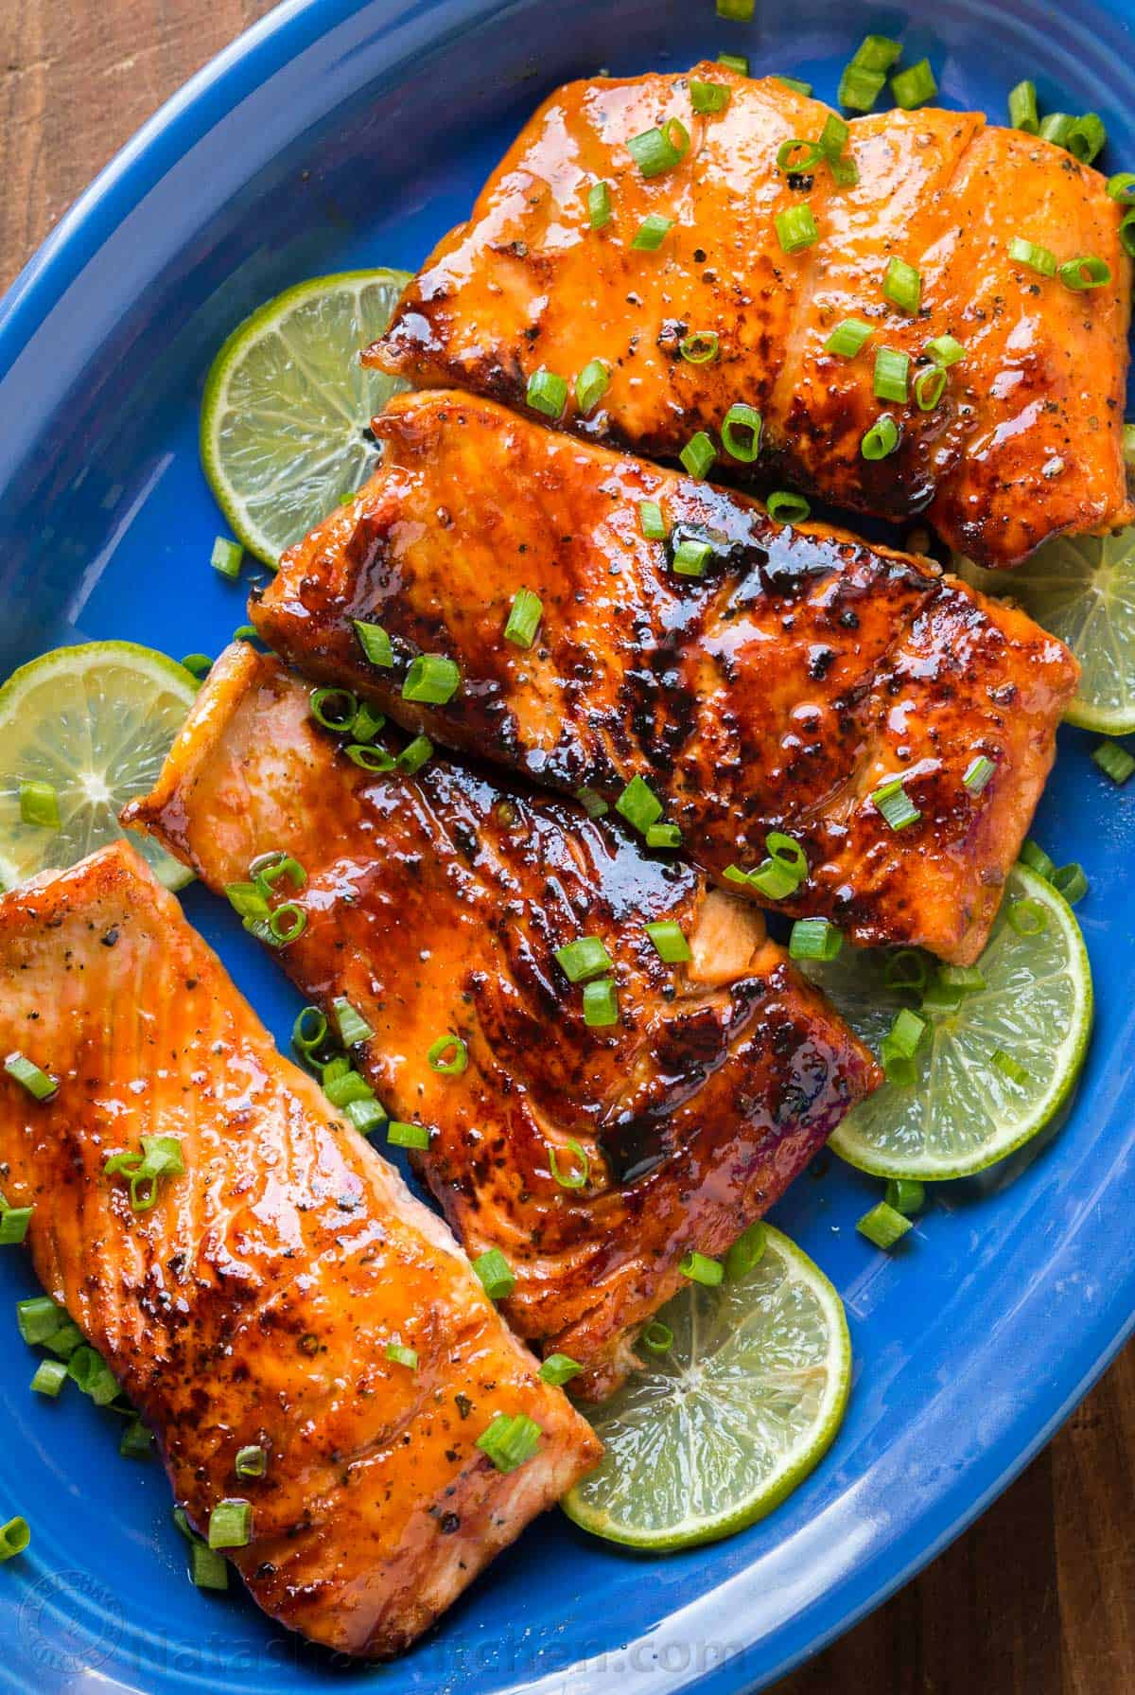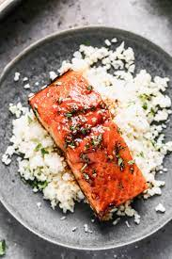

**General Tso’s Tofu (v)**

*This spicy and sweet tofu has a perfect blend of flavors, is one of my favorite tofu recipes, and healthier. It’s great for those looking for a healthier dish!*

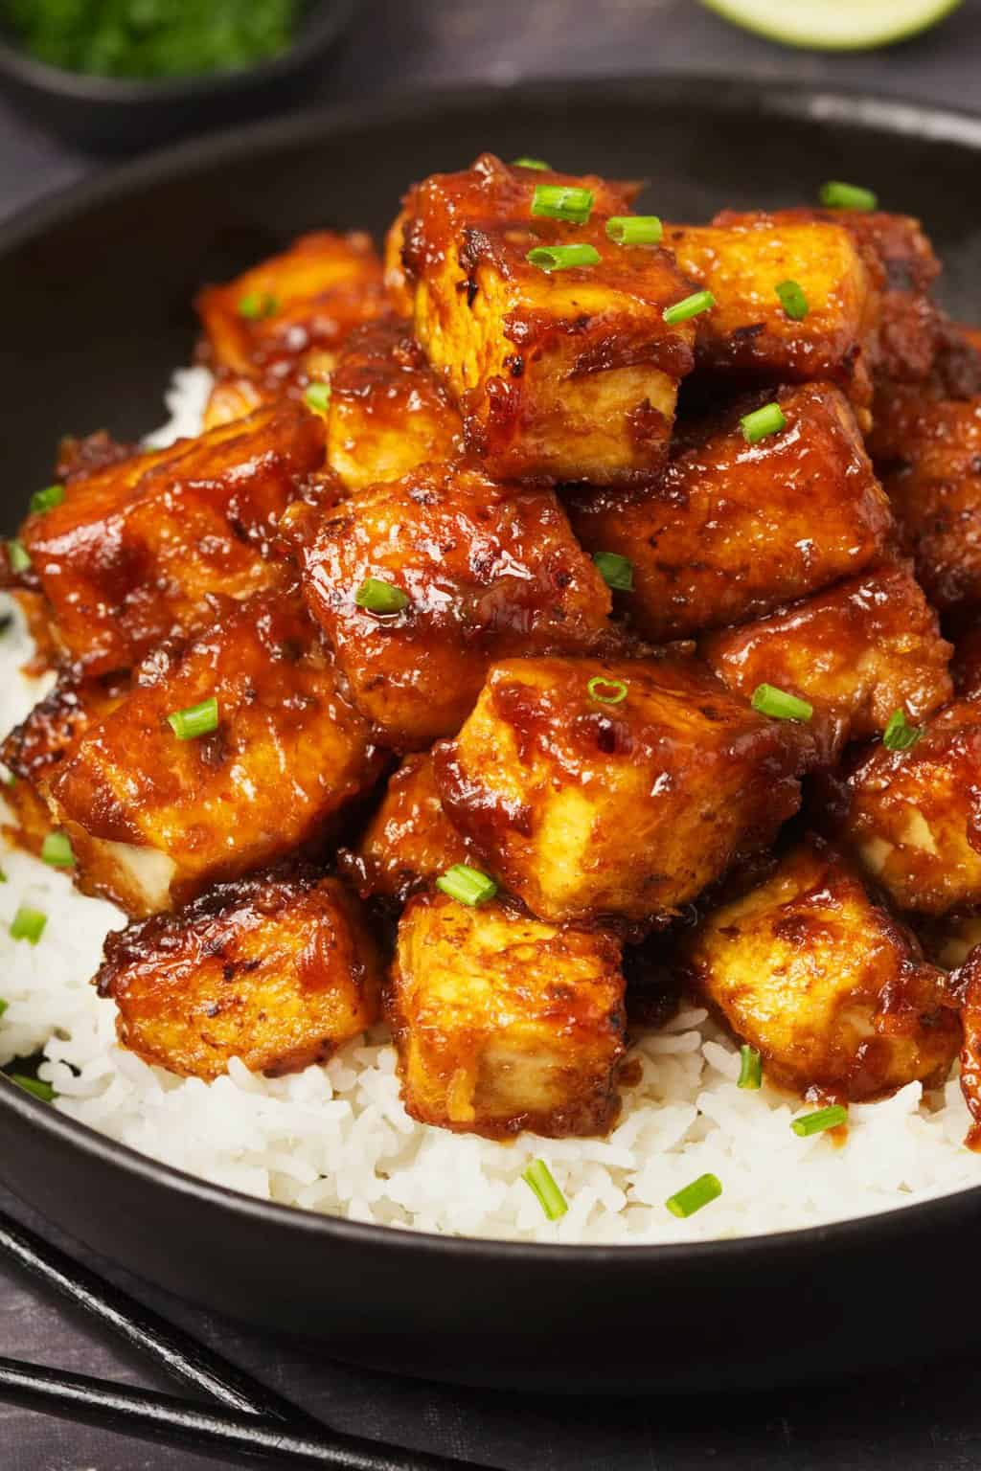

#### **Ingredients:**

#### **Tofu**

* 10 ounces firm tofu (275 g), cubed
* 2 tbsp tamari or soy sauce
* 1 tbsp apple cider vinegar
* 6 tbsp cornstarch
* Oil of your choice, I used extra virgin olive oil
* 2 cloves of garlic, minced

#### **For the sauce**

* 3 tbsp tamari or soy sauce
* 3 tbsp apple cider vinegar, see notes
* 3 tbsp [vegetable stock](https://simpleveganblog.com/vegetable-stock-oil-free/) or water
* 3 tbsp cane, coconut or brown sugar
* 1 tbsp cornstarch
* 1/8 tsp red pepper flakes, optional

### **Instructions**

1. Place the tofu cubes in a bowl or shallow dish.
2. Add the marinade ingredients (2 tbsp of tamari and 1 tbsp of apple cider vinegar), stir and let rest for at least 5 minutes, preferably overnight.
3. Drain the tofu and discard the marinade.
4. Transfer 1/3 of the tofu cubes to a freezer or plastic bag with 2 tbsp of cornstarch and toss to coat. Repeat this step with the rest of the tofu cubes and cornstarch. Add more cornstarch if needed.
5. Once the tofu cubes are coated with the cornstarch, heat some oil in a skillet and add the tofu cubes. I used extra virgin olive oil, but any oil will do.
6. Cook the tofu cubes over medium-high heat until all sides are golden brown. Remove the tofu from the skillet and set aside.
7. Add the garlic to the skillet (add more oil if needed) and cook over medium-high heat for about 1 to 2 minutes, stirring frequently until golden brown. Set aside.
8. Mix all the sauce ingredients in a bowl (tamari or soy sauce, apple cider vinegar, vegetable stock or water, sugar, cornstarch and red pepper flakes). Set aside.
9. Add the sauce to the skillet where you had your cooked garlic and cook over medium-high heat until it thickens, stirring frequently.
10. Finally, add the tofu cubes, stir and cook for 1 to 2 more minutes.
11. Serve with some cooked white rice and garnish with some sesame seeds and chopped chives (optional). Keep leftovers in an airtight container in the fridge for up to 5 days.

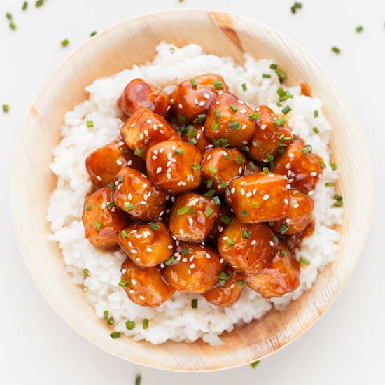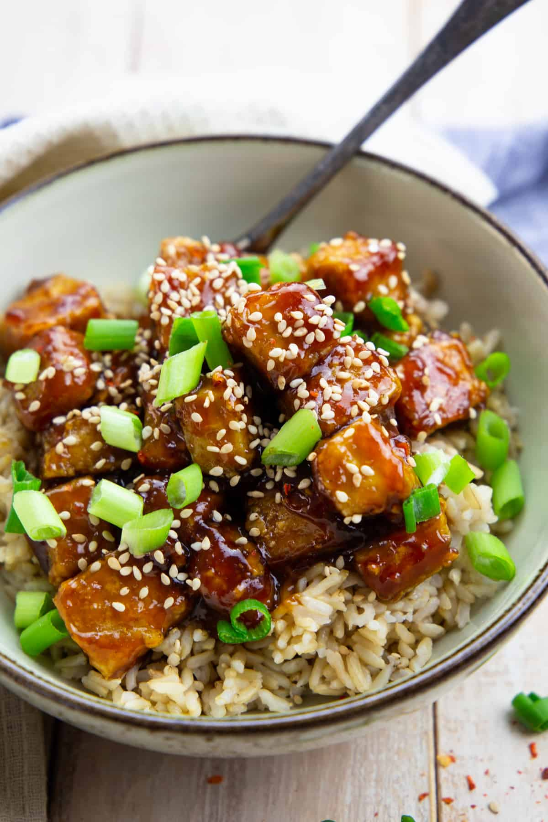

### 

### 

### 

### 

### **Chocolate Cupcakes (V, Gf)**

*These moist, rich cupcakes can be paired with both vanilla and chocolate frosting and are the PERFECT chocolatey treat for any day.*

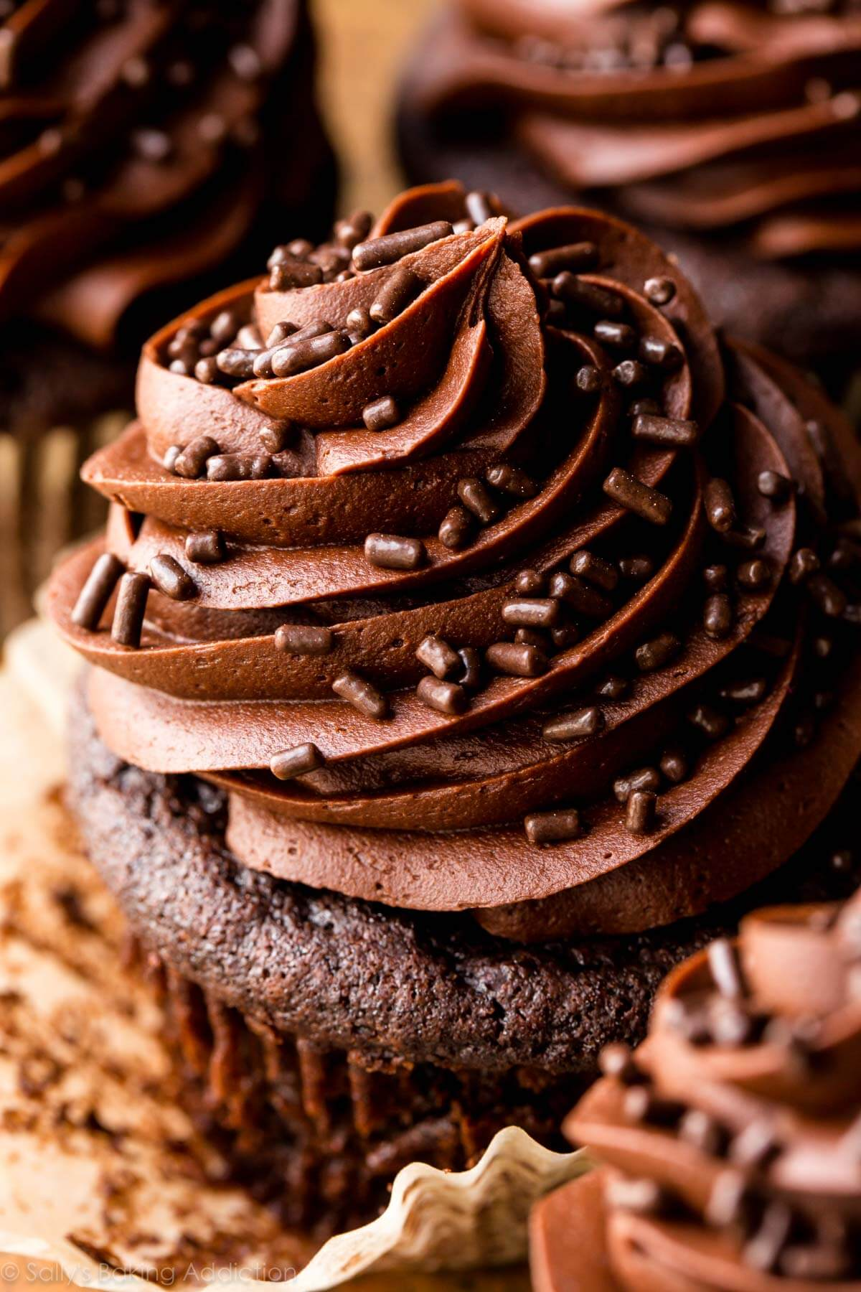

#### **Ingredients**

* 1 ½ cups gluten free oat flour – *if using* [*homemade oat flour*](https://beamingbaker.com/how-to-make-homemade-oat-flour-gluten-free-vegan/)*, make sure it’s very finely ground (not coarse)\**
* 2/3 cup unsweetened cocoa powder
* 1 teaspoon baking soda
* ¼ teaspoon salt
* ½ cup + 2 tablespoons water
* ½ cup non-dairy milk
* 3 tablespoons melted [coconut oil](https://beamingbaker.com/recommends/coconut-oil/)
* ¼ cup [coconut sugar](https://beamingbaker.com/recommends/coconut-sugar/)
* ¼ cup [pure maple syrup](https://beamingbaker.com/recommends/maple-syrup/)
* 1 teaspoon [pure vanilla extract](https://beamingbaker.com/recommends/pure-vanilla-extract/)

**Instructions**

* Prepare the frosting: The night before, begin preparing one batch of this [Vegan Chocolate Frosting](https://beamingbaker.com/make-homemade-chocolate-frosting-vegan-paleo-gluten-free-dairy-free-refined-sugar-free/). Do not whip the frosting until the cupcakes are cooled and ready to be frosted.
* Make the cupcakes: Preheat the oven to 350°F. Line a [12-cup muffin pan](https://beamingbaker.com/recommends/mini-muffin-pan/) with [cupcake liners](https://beamingbaker.com/recommends/parchment-cupcake-liners/). Set aside.
* In a large bowl, [sift together](https://beamingbaker.com/recommends/bellemain-stainless-steel-3-cup-flour-sifter/) the dry ingredients: oat flour, cocoa powder, baking soda and salt.
* Add water and milk to a microwave-safe bowl. Heat in 10-second increments until just warm. This will prevent the melted coconut oil from solidifying once mixed with these liquids.
* In a medium bowl, whisk together all wet ingredients: water, milk, coconut oil, sugar, maple syrup and vanilla. Whisk until well incorporated. Add wet ingredients to dry ingredients. Whisk until just incorporated, making sure no flour patches remain.
* Pour batter evenly into prepared muffin pan—filling each cup about 3/4 of the way. Bake for 16-20 minutes. Mine took 18 minutes. Test for doneness with a toothpick. The toothpick should come out with a few dry bits of cake on it, but no liquidy batter.
* Place muffin pan on a [cooling rack](https://beamingbaker.com/recommends/cooling-rack/) to cool for 30 minutes. Remove cupcakes from muffin pan and continue cooling on rack until completely cool before frosting.
* Frost the cupcakes: Whip the frosting [as instructed](https://beamingbaker.com/make-homemade-chocolate-frosting-vegan-paleo-gluten-free-dairy-free-refined-sugar-free/). Frost the cupcakes. Enjoy!

